 | 12.1.6 Editors - Geometry Nodes Editor - Header - Add Menu - Input - Constant
Table of content
Detailed table of content 1
Add menu - Input - Constant 3
Boolean 3
Collection 3
Color 4
Font 4
Image 5
Integer 6
Material 6
Object 6
Rotation 7
String 7
Value 7
Vector 8

Detailed table of content
Detailed table of content
Detailed table of content 1
Add menu - Input - Constant 3
Boolean 3
Properties 3
Value 3
Outputs 3
Boolean 3
Collection 3
Properties 3
Collection 3
Outputs 4
Collection 4
Color 4
Outputs 4
Color 4
Font 4
Parameters 4
Font Selector 4
Output 4
Image 5
Properties 5
Image 5
New 5
Open 5
Image prop 5
Image browser 5
Image name 5
Fake user 5
New 5
Open Image 5
Remove 5
Frame 5
Outputs 6
Image 6
Integer 6
Properties 6
Value 6
Outputs 6
Integer 6
Material 6
Outputs 6
Material 6
Object 6
Properties 6
Object 6
Outputs 6
Object 6
Rotation 7
Properties 7
X, Y Z 7
Outputs 7
Rotation 7
String 7
Properties 7
String 7
Outputs 7
Value 7
Value 7
Properties 7
Value 7
Outputs 8
Value 8
Vector 8
X Y Z 8
Output 8
Vector 8

Add menu - Input - Constant
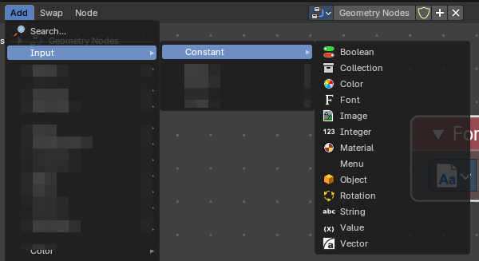
Here you find input nodes.

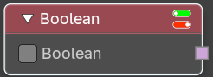
Boolean
Inputs a boolean value.

Properties

Value
The input boolean.

Outputs

Boolean
The boolean state.

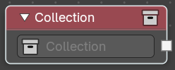
Collection
Outputs a single collection.

Properties

Collection
The collection to select from the scene.

Outputs

Collection
The collection data useful to get instances as children.

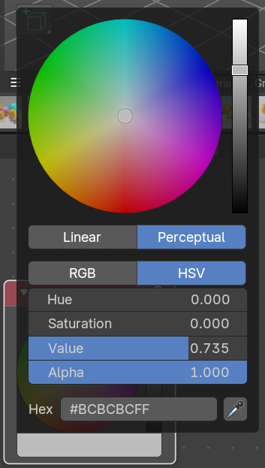
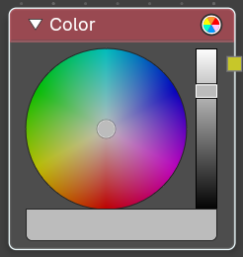
Color
Define a input color.
This node is a color wheel.
Clicking at the color field at the bottom will reveal the standard Blender color dialog, where you can input numeric values.

Outputs

Color
Standard color output.

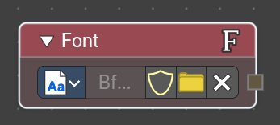
Font
Provides a constant reference to a font data inside Geometry Nodes. Useful for procedural text generation, typography-driven effects, and node-based workflows where font consistency is required

Parameters

Font Selector
Dropdown or file browser to choose the font datablock. Can reference internal fonts or external font files.

Output
Provides a Font datablock reference that other nodes can consume. Typically used as input for text-related nodes.

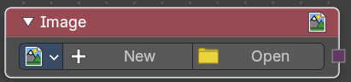
Image
Add a input image.

Properties

Image
Load or connect a image.

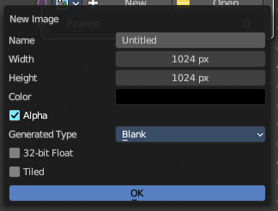
New
Create a new image.
Opens a new image dialog where you can adjust the color, size and further settings.

Open
Open a existing image.

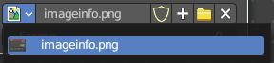
Image prop

Image browser
A list of available images

Image name
The name of the image

Fake user
Add a fake user to this asset.

New
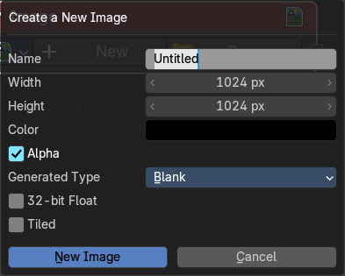
Create a new image.
Opens a new image dialog where you can adjust the color, size and further settings.

Open Image
Open a existing image.

Remove
Removes the image as the active image.

Frame
For videos. Which frame to use.

Outputs

Image
The output image.

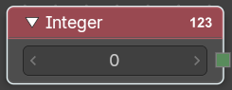
Integer
Inputs a integer value.

Properties

Value
The input integer.

Outputs

Integer
The integer value.

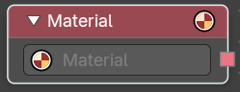
Material
Retreive a material.

Outputs

Material
The material output.

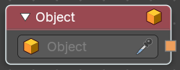
Object
Retrieves a single object.

Properties

Object
The object to select from the scene.

Outputs

Object
The object data useful to get object info.

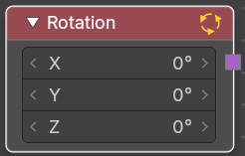
Rotation
Apply a constant rotation.

Properties

X, Y Z
The rotation that you want to apply.

Outputs

Rotation
The output rotation vector.

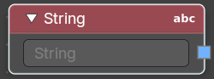
String
Input a string.

Properties

String
The string that you want to input.

Outputs

Value
The value set in the node properties.

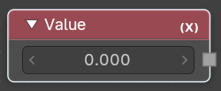
Value
Input numerical values to other nodes in the tree.

Properties

Value
Single numerical value (floating point).

Outputs

Value
The value set in the node properties.

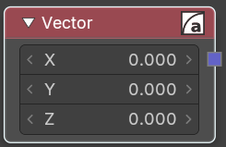
Vector
Creates a single vector of three values that can be used as an input.
Properties

X Y Z
The values of the vector.

Output

Vector
Standard vector output.

